

Name: Abdulrahman Alawadhi
PRN: 25070122008
Branch: CSE
Subject: Programming with Java

ASSIGNMENT No.: 9
TITLE: Write a Java program to demonstrate the use of the final keyword with variables, methods, and classes.

Problem Statement:
Write a Java program to demonstrate the use of the final keyword with variables, methods, and classes.

Learning Objectives:

To implement the final keyword with variables, methods, and classes.

Theory:

The final keyword restricts modification in Java programs. A final variable cannot be reassigned after initialization. A final method cannot be overridden by subclasses, while a final class cannot be inherited. This improves security, prevents accidental modifications, and increases program reliability. Final is commonly used for constants and immutable classes.

Outcomes:
The final keyword was successfully applied to a variable, a method, and a class, demonstrating that final variables cannot be reassigned, final methods cannot be overridden, and final classes cannot be inherited.

class Constants {
final double PI = 3.14159;

void showPI() {
System.out.println("Value of PI: " + PI);
}
}

class Vehicle_ {
final void showType() {
System.out.println("This is a generic vehicle");
}
}

class Car extends Vehicle_ {

void showBrand() { System.out.println("This is a Car");
}
}

final class Utility { void printMessage() {
System.out.println("Utility class method called");
}
}

public class JAVA_EXP_9 {
public static void main(String[] args) {

// 1. final variable
Constants c = new Constants(); c.showPI();
// c.PI = 3.15; // Not allowed - compile-time error, PI is final

System.out.println();

// 2. final method Car car = new Car(); car.showType(); car.showBrand();

System.out.println();

// 3. final class
Utility u = new Utility(); u.printMessage();
}
}

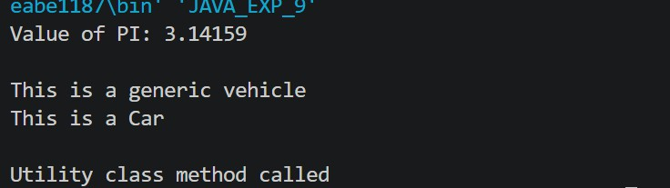

Conclusion:

The final keyword is a useful tool for enforcing immutability and restricting extension in Java. It protects critical data (like account numbers or ISBNs) from accidental modification, prevents subclasses from altering core method behaviour, and can lock a class design against further inheritance — all of which improve the security and reliability of a program.

Exercise:

- Create a Bank Account program where account number is final and cannot be changed.
class BankAccount {
final String accountNumber; String accountHolderName; double balance;

BankAccount(String accountNumber, String accountHolderName, double balance) { this.accountNumber = accountNumber;
this.accountHolderName = accountHolderName; this.balance = balance;
}

void deposit(double amount) { balance += amount;
System.out.println("Deposited: " + amount + " | New Balance: " + balance);
}

void withdraw(double amount) {

if (amount > balance) { System.out.println("Insufficient balance!");
} else {
balance -= amount;
System.out.println("Withdrawn: " + amount + " | New Balance: " +
balance);
}
}

void showAccountDetails() {
System.out.println("Account Number : " + accountNumber); System.out.println("Account Holder : " + accountHolderName); System.out.println("Balance : " + balance);
}
}

public class JAVA_EXP_9 {
public static void main(String[] args) {
BankAccount acc = new BankAccount("ACC10023456", "Priya Deshmukh", 15000.0);

acc.showAccountDetails(); System.out.println();

acc.deposit(5000); acc.withdraw(2000);

// acc.accountNumber = "ACC99999999"; // Not allowed - compile-time error, accountNumber is final

System.out.println(); acc.showAccountDetails();
}
}
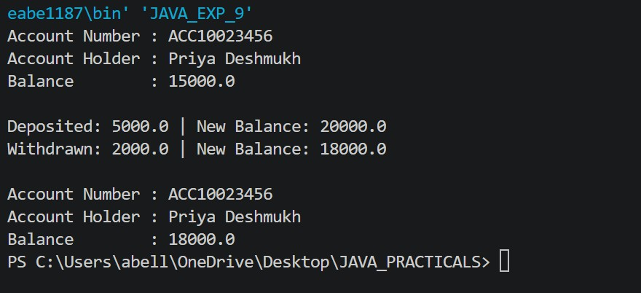

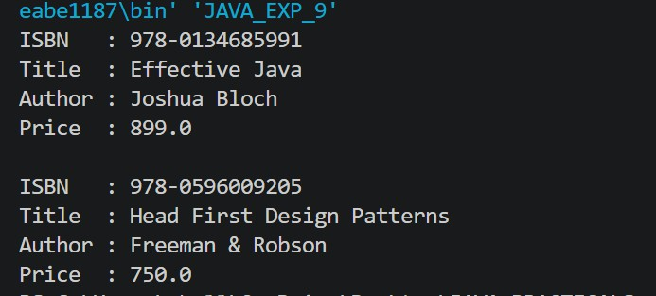
- Create a Library Book Management program where the book ISBN is declared as final and cannot be changed once assigned. Display the book's ISBN, title, author, and price.
class Book {
final String ISBN; String title; String author; double price;

Book(String ISBN, String title, String author, double price) { this.ISBN = ISBN;
this.title = title; this.author = author; this.price = price;
}

void displayBookDetails() { System.out.println("ISBN : " + ISBN); System.out.println("Title : " + title); System.out.println("Author : " + author); System.out.println("Price : " + price);
}
}

public class JAVA_EXP_9 {
public static void main(String[] args) {
Book b1 = new Book("978-0134685991", "Effective Java", "Joshua Bloch",
899.0);
Book b2 = new Book("978-0596009205", "Head First Design Patterns", "Freeman & Robson", 750.0);

b1.displayBookDetails(); System.out.println(); b2.displayBookDetails();

// b1.ISBN = "978-0000000000"; // Not allowed - compile-time error, ISBN
is final
}
}

